**Bruhati Problem Statement** :

The scenario is as follow:

* A current HTTP Post exists, and the data needs to be collected and forwarded to another software.
* The URL to retrieve the data is: <http://172.16.10.22/fx9600/bancali_imp>
* No authentication is required
* On receiving a message, the data needs to be forwarded as MQTT to:
  + //bruhati.eu-latest.cumulocity.com
* Format of message needs to be (JSON message,ID,Name)
  + JSON message sample {timeStamp:value,antennaPort:value,epc:value}
* **NB The connection to the location is not given, and the device does not exist in the endpoint, thus the code is not expected to push the data. Please ensure the code is commented and that where you believe more information is required to make an assumption or state what is missing.**
* Sample code expected from the HTTP Post is:
  + {  
      **"reader_name": "FX9600F60A34 FX9600 RFID Reader",  
      "mac_address": "84:24:8D:F6:0A:34",**  
      "tag_reads": [  
        **{  
          "epc": "202202211620000000000009",  
          "antennaPort": "1",  
          "timeStamp": "08/04/2022 09:40:31:446"  
        },**  
        {  
          "epc": "2022030200000000000000BB",  
          "antennaPort": "1",  
          "timeStamp": "08/04/2022 09:40:31:447"  
        },  
        {  
          "epc": "2022030200000000000000CC",  
          "antennaPort": "1",  
          "timeStamp": "08/04/2022 09:40:31:447"  
        },  
        {  
          "epc": "2022030200000000000000EE",  
          "antennaPort": "1",  
          "timeStamp": "08/04/2022 09:40:31:448"  
        }  
      ]  
    }

**Step 1:**

I was trying to retrieve the data from this url:

<http://172.16.10.22/fx9600/bancali_imp>

Through this url, I was trying to retrive the json data by using postman:

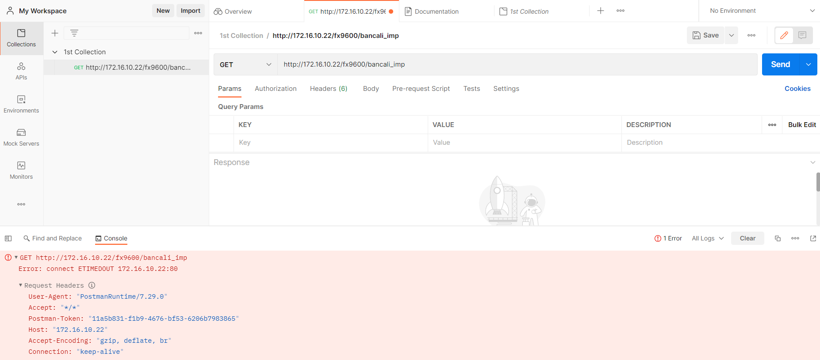

But I did not get the data…

After this,

I tried to ping this ip, but it’s not working.

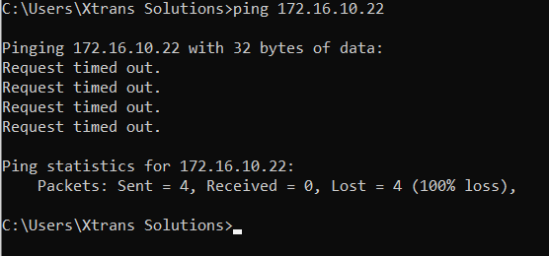

Data 100% lost.

But anyway my second goal is to: the data needs to be forwarded as MQTT to

* + //bruhati.eu-latest.cumulocity.com

For forwarding the data I need few credentials like topic, broker address and port. That is not mentioned in this problem statement. So, I am writing general code for this problem statement.

Please follow the link:

[kmp99/BruhatiDemo (github.com)](https://github.com/kmp99/BruhatiDemo)

main.py